

University of Engineering & Technology Mardan
Department of Computer Software Engineering

Submitted By | Umar Hayat
Semester | 6th, Spring 2026
Registration No | 23MDSWE274
Batch | 06
Subject | HCI Lab
Submitted To | Dr. Hamid Ullah
Lab Task # 11

Lab Task 1: Heuristic Evaluation
For this task, we evaluate the provided app screens against Nielsen's Revised 10 Usability Heuristics.
Observation / Problem Found | Violated Heuristic | Explanation & Recommendation
Missing "Back" Navigation: Once a user clicks "Book Now" and goes to the table selection screen, there is no top "Back" arrow to return to the search results. | User control and freedom | Users might select the wrong restaurant and need an "emergency exit" to go back without navigating all the way home. Recommendation: Add a back arrow in the top header.
Ambiguous Table Status Colors: On the "Choose Table" screen, table icons are red and grey, but there is no legend to explain what these colors mean (e.g., Available vs. Booked vs. Selected). | Visibility of system status | The system does not clearly communicate its current state to the user. Recommendation: Add a small color legend next to the tables.
Unclear Date Formatting: On the "Book Later" screen, the date input simply shows / / without specifying if the format should be DD/MM/YYYY or MM/DD/YYYY. | Error prevention | This ambiguity can lead to users booking for the wrong month or day. Recommendation: Provide placeholder text like DD/MM/YYYY or use a standard calendar pop-up.
Cluttered/Squeezed Navigation Text: On the bottom navigation bar, the word "Notifications" is squeezed together and uses a smaller font size compared to the other icons. | Aesthetic and minimalist design | The visual layout is compromised, making it slightly harder to read. Recommendation: Shorten the label to "Alerts" or adjust the icon spacing to allow for a consistent font size.
Ambiguous Icon Actions: On the "Bookings" screen, there are red X icons next to restaurant names. It is not immediately clear if this deletes the history or cancels an active booking without a warning. | Help users diagnose and recover from errors | Clicking 'X' by accident could have severe consequences. Recommendation: Ensure tapping the 'X' triggers a confirmation dialogue (e.g., "Are you sure you want to cancel this booking?").

Lab Task 2: Cognitive Walkthrough
Task: Table reservation User Persona: First-time user not too familiar with technology
In a cognitive walkthrough, we analyze the steps the user takes from the perspective of our specific persona, asking four key questions at each step.
Step & User Goal | Is the action obviously available? | Does the action or label match the goal? | Is there good feedback?
Step 1: The user wants to search for a restaurant. | Yes: The bottom navigation has a clear "Search" icon, and the search bar is prominently placed at the top of the screen. | Yes: The magnifying glass icon and the word "Search" are universally understood, even by non-tech-savvy users. | Yes: The system displays a list of restaurant results immediately below the search bar.
Step 2: The user wants to initiate the booking process. | Yes: Distinct red "Book Now" and "Book Later" buttons are clearly visible under each restaurant listing. | Yes: The labels are direct and straightforward, perfectly matching the user's intent to reserve a table. | Yes: Tapping the button transitions the user directly to the table selection/time selection screen.
Step 3: The user wants to select a specific table. | Yes: Large table icons (fork and knife) are displayed beneath a photo of the restaurant's layout. | No: A user unfamiliar with technology will struggle to guess what the red versus grey colors mean. They must spend cognitive effort guessing if red means "taken," "available," or "currently selected." | Unclear: The static prototype does not show immediate textual feedback upon tapping a table (e.g., a "Table 3 Selected" prompt) before hitting the final submit button.
Step 4: The user wants to finalize the reservation. | Yes: There is a large "Book Now" or "Book For Later" button at the bottom of the final screen. | Yes: The label clearly indicates the final step to confirm the transaction. | Yes: As seen in the final screen, the system provides feedback by adding a confirmation message to the "Notifications" tab.

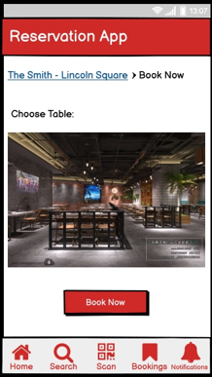
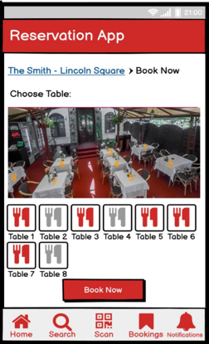
This analysis covers both the heuristic violations and the step-by-step cognitive perspective required for your graded tasks! Let me know if you need help formatting this into your final report.

Github Repository:
https://github.com/umarhayat1651/HCI-Labs

